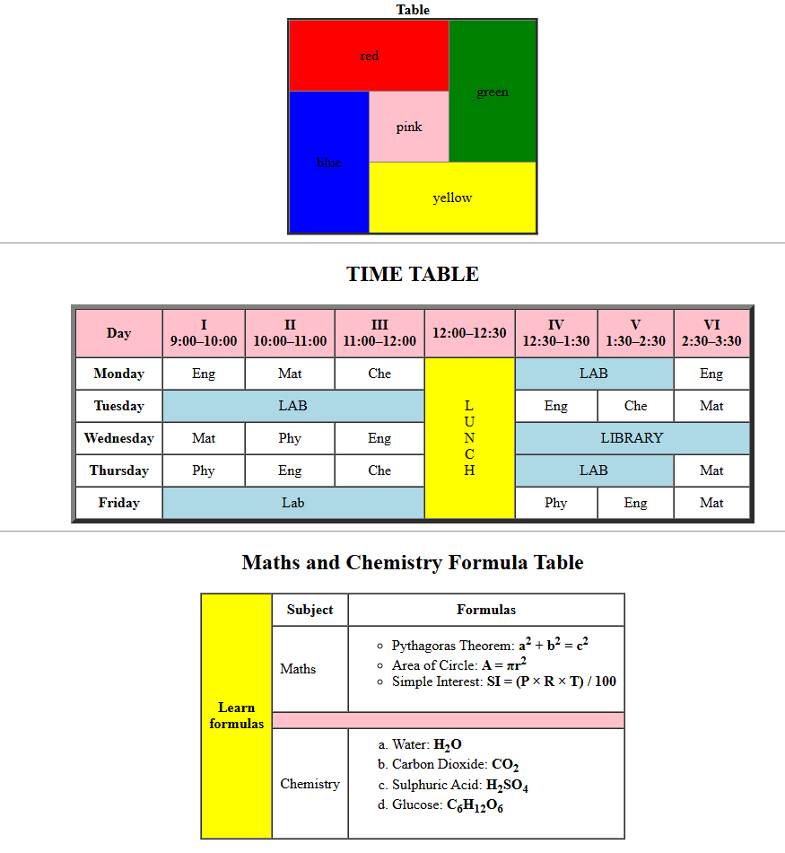

<!--table 1-->

<table align="center" border="3" rules="all" cellpadding="30">

    <caption><b>Table</b></caption>

    <tr align="center">

        <td colspan="2" bgcolor="red">red</td>

        <td rowspan="2" bgcolor="green">green</td>

    </tr>

    <tr align="center">

        <td rowspan="2" bgcolor="blue">blue</td>

        <td bgcolor="pink">pink</td>

    </tr>

    <tr align="center">

        <td colspan="2" bgcolor="yellow">yellow</td>

    </tr>

</table>

<!--table 2-->

<hr>

<h2 style="text-align:center;">TIME TABLE</h2>

  <table border="5" cellspacing="0" cellpadding="8" align="center">

    <tr align="center" bgcolor="pink">

      <th>Day</th>

      <th>I<br>9:00–10:00</th>

      <th>II<br>10:00–11:00</th>

      <th>III<br>11:00–12:00</th>

      <th>12:00–12:30</th>

      <th>IV<br>12:30–1:30</th>

      <th>V<br>1:30–2:30</th>

      <th>VI<br>2:30–3:30</th>

    </tr>

    <tr align="center">

      <th>Monday</th>

      <td>Eng</td>

      <td>Mat</td>

      <td>Che</td>

      <td rowspan="6" bgcolor="yellow">L<br>U<br>N<br>C<br>H</td>

      <td colspan="2" bgcolor="lightblue">LAB</td>

      <td>Eng</td>

    </tr>

    <tr align="center">

      <th>Tuesday</th>

      <td colspan="3" bgcolor="lightblue">LAB</td>

      <td>Eng</td>

      <td>Che</td>

      <td>Mat</td>

    </tr>

    <tr align="center">

      <th>Wednesday</th>

      <td>Mat</td>

      <td>Phy</td>

      <td>Eng</td>

      <td colspan="3" bgcolor="lightblue">LIBRARY</td>

    </tr>

    <tr align="center">

      <th>Thursday</th>

      <td>Phy</td>

      <td>Eng</td>

      <td>Che</td>

      <td colspan="2" bgcolor="lightblue">LAB</td>

      <td>Mat</td>

    </tr>

    <tr align="center">

      <th>Friday</th>

      <td colspan="3" bgcolor="lightblue">Lab</td>

      <td>Phy</td>

      <td>Eng</td>

      <td>Mat</td>

    </tr>

  </table>

<hr>

<!--table 3-->

  <h2 style="text-align:center;">Maths and Chemistry Formula Table</h2>

  <table border="1" cellpadding="8" cellspacing="0" align="center">

    <tr>

      <th rowspan="4" bgcolor="yellow">Learn<br> formulas</th>

      <th>Subject</th>

      <th>Formulas</th>

    </tr>

    <!-- Maths formulas -->

    <tr>

      <td>Maths</td>

      <td>

        <ul type="Circle">

          <li>Pythagoras Theorem: <b>a<sup>2</sup> + b<sup>2</sup> = c<sup>2</sup></b></li>

          <li>Area of Circle: <b>A = πr<sup>2</sup></b></li>

          <li>Simple Interest: <b>SI = (P × R × T) / 100</b></li>

        </ul>

      </td>

    </tr>

    <tr><td colspan="2" bgcolor="pink"></td></tr>

    <!-- Chemistry formulas -->

    <tr>

      <td>Chemistry</td>

      <td>

        <ol type="a">

          <li>Water: <b>H<sub>2</sub>O</b></li>

          <li>Carbon Dioxide: <b>CO<sub>2</sub></b></li>

          <li>Sulphuric Acid: <b>H<sub>2</sub>SO<sub>4</sub></b></li>

          <li>Glucose: <b>C<sub>6</sub>H<sub>12</sub>O<sub>6</sub></b></li>

        </ol>

      </td>

    </tr>

  </table>